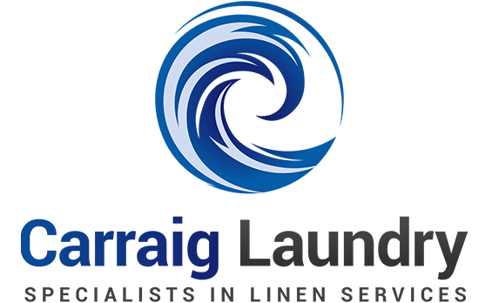

GENDER PAY
GAP REPORT
2026
CARRAIG LAUNDRY
Snapshot date 1 June 2026
Reporting period 1 June 2025 to 1 June 2026
Gender pay gap disclosure

TABLE OF CONTENTS
01 Introduction 3
02 Definitions 4
03 Source of Data 6
04 Adjustments and Approximations 6
05 Employment Profile 6
06 Gender Pay Gap Profile 7
07 Gender Breakdown by Quartile 8
08 Analysis 8
09 Conclusion 8
This report presents Carraig Laundry’s employment profile, gender pay gap results and approach to equality in the workplace.

01 INTRODUCTION
Carraig Laundry acknowledges the value of diversity and gender parity in the workplace. We are dedicated to promoting gender equity and building a working environment where everyone has equal opportunities to succeed. Our organisation is committed to fostering an inclusive, equal, and diverse workforce, and to closing the gender pay gap (GPG). This report provides a transparent overview of our gender pay gap and the actions we are taking to address it, highlighting our progress towards achieving greater equality.
The provision of equal pay between men and women is a key policy priority. In response, the Government enacted the Gender Pay Gap Information Act in July 2021. From 2025 onwards, all organisations in Ireland with over 50 employees are required to report annually on their gender pay gap.
This report represents our organisation’s first formal GPG disclosure, based on data for the 2026 reporting period. It provides a baseline from which we will measure future progress.
The Gender Pay Gap Information Act 2021 introduced the statutory framework for gender pay gap reporting in Ireland and requires organisations to disclose data on their hourly GPG.
Organisations subject to the legislation must select a “snapshot” date in the month of June to base their reporting. Our chosen snapshot date is 1st June, 2026. A headcount of all employees on this date was carried out, and gender pay information was calculated based on the remuneration of those employees between 1st June, 2025 and 1st June, 2026.

67  TOTAL EMPLOYEES | 33  MALE EMPLOYEES | 34  FEMALE EMPLOYEES

23.8%  MEAN SALARY GAP | 11.4%  MEAN HOURLY GAP | 16.1%  MEAN BONUS GAP

This report explores the contributing factors to the pay gap and outlines the measures we are taking to reduce it over time.

02 DEFINITIONS
Gender Pay Gap (GPG): The gender pay gap is usually represented as the average difference in gross hourly earnings of men and women, expressed as a percentage of men's average gross hourly earnings. A positive gender pay gap indicates that, on average across the employed population, women are in a less favourable position than men. Where the gender pay gap is negative, this indicates the reverse - that, on average, men are in a less favourable position than women.
Relevant date: means the date, in the month of June each year that is selected by a relevant employer for the purposes of the report.
Relevant employee: means a person who is an employee for the purposes of the Employment Equality Act 1998 and is employed by the relevant employer on the snapshot date.
Relevant employer: means an employer with over 150 employees on the snapshot date.
Relevant pay period: means the period of 12 months ending on the snapshot date.
Shift premium pay: means the difference between basic pay and any higher rate paid by the employer for work during different times of the day or night.
Working hours: means the hours when a relevant employee is available, or required to be available, at or near his or her place of employment for the purposes of working, but does not include the hours when the relevant employee is asleep, notwithstanding that the relevant employee, by arrangement, sleeps at or near his or her place of employment and the relevant employer provides suitable sleeping facilities for that relevant employee.
Employee Hourly Rate: The hourly remuneration of an employee is calculated by dividing the employees’ total ordinary pay in respect of the reporting period by the hours worked for that period. Ordinary pay includes: the normal salary paid to the employee; allowances; overtime; shift premium pay; pay for sick leave; any salary top-ups for statutory leave such as maternity / paternity / parents leave.
Mean Hourly GPG: The mean gender pay gap is the difference in the arithmetic average hourly pay for women compared to men, within our organisation.
Median Hourly GPG: The median gender pay gap is the difference between women’s median hourly pay (the middle-paid woman) and men’s median hourly pay (the middle-paid man). The median hourly pay is calculated by ranking all employees from the highest paid to the lowest paid and taking the hourly pay of the person in the middle.

DEFINITIONS CONTINUED
Quartiles: Employees were organised into quartiles based on hourly remuneration of all male and female full-time employees: lower, lower middle, upper middle and upper. The proportion of male and female employees in each quartile was expressed as a percentage. There is no requirement to show this information for part-time employees or for temporary employees.
Snapshot Date: Employers to whom the reporting obligations apply are required to calculate and publish the gender pay gap information in respect of relevant persons employed by them on the chosen snapshot date, with the calculations to be based on those employees' remuneration for the 12-month period that precedes the snapshot date. Employers are required to choose a snapshot date. The snapshot date must be in June but may be any date in June.
Equal pay: The principle of equal pay does not mean that all workers must be paid equally; it means that any pay differences must be based on objective criteria, not related to gender.
Ordinary pay: means the following types of remuneration, payable to a relevant employee, before any statutory deductions are made –
• Basic pay,
• Allowances,
• Pay for piece-work,
• Shift premium pay, or
• Overtime pay,
• Pay for sick leave,
• Any salary top-ups for statutory leaves like maternity leave/paternity leave/parent’s leave/adoptive leave,
• Pay for gardening leave.
But does not include -
• Remuneration referable to redundancy or termination of employment, or
• Remuneration other than money
Part-time working: A part-time employee in Ireland is defined in law as an employee whose normal hours of work are less than the normal hours of work of an employee who is a comparable employee. For this paper anyone whose full-time employment status (FTE) is less than one is assumed to be working part-time. Part-time does not include anyone who is on or has taken unpaid leave during the reporting period, for example parental leave.

03 SOURCE OF DATA
The data for this report was provided by the organisation’s payroll system.

04 ADJUSTMENTS AND APPROXIMATIONS
On 1st June, 2026 the total headcount of Carraig Laundry was 67 employees. The employee breakdown is the source of the report's metrics, which show the percentage of male and female employees on the snapshot date.
Employees on unpaid leave, such as career breaks (i.e. employees who are on career breaks for over 12 months), who have received no pay during the reporting period are included in the headcount, but not included in the report.
Employees on sick leave are included in the report.

05 EMPLOYMENT PROFILE
On 1st June, 2026 there were 67 employees in Carraig Laundry.
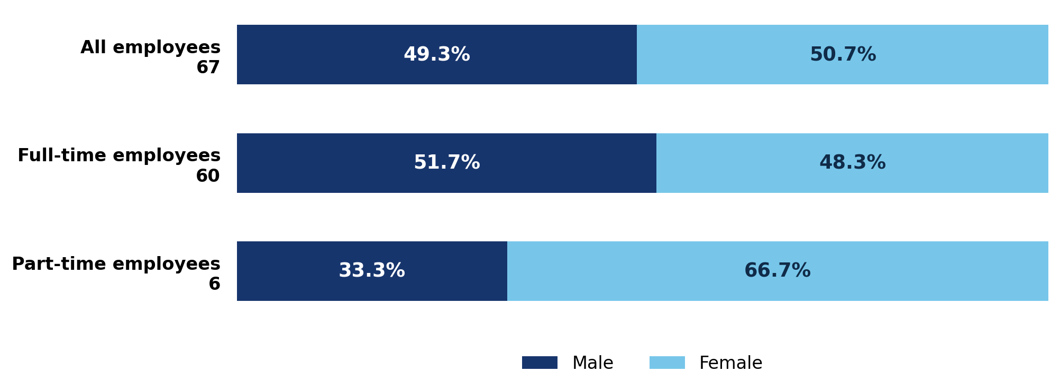
Key: dark blue = male; light blue = female. Each bar represents 100% of the named employee group. The number beside each group is its total headcount. For example, 49.3% of all 67 employees are male (33) and 50.7% are female (34).

Reporting categories
The Gender Pay Gap Information Act 2021 requires mean and median gender pay gap percentages across three categories: all employees, part-time employees and temporary employees.

06 GENDER PAY GAP PROFILE
The GPG is the difference in the average hourly wage of males and females across a workforce. It does not take into account any other factors (for example, years of service, grade or any period of statutory leave).
Measure and employment group | Mean pay gap | Median pay gap
Salary — all employees | 23.8% | 5.7%
Salary — full-time employees | 17.9% | 7.7%
Salary — part-time employees | −10.5% | −5.3%
Hourly remuneration — all employees | 11.4% | 7.1%
Hourly remuneration — full-time employees | 10.7% | 8.8%
Hourly remuneration — part-time employees | −9.7% | −4.6%
Bonus comparison | 16.1% | 0.0%

BONUSES AND BENEFITS IN KIND
Measure | Total | Male | Female | Difference  (percentage points)
Employees who received a bonus | 76.1% | 69.7% | 82.4% | 12.7 in favour of females
Employees who received a benefit in kind | 6.0% | 6.1% | 5.9% | 0.2 in favour of males

Mean = average pay; median = middle-ranked pay. Pay gaps are expressed as a percentage of the male figure. Positive gaps favour males; negative gaps favour females; 0% indicates no gap. Salary comparisons are supplementary to the hourly remuneration measures.
Bonus and benefit receipt figures show the percentage of employees in each group who received the benefit. Differences between male and female receipt rates are shown in percentage points.

07 GENDER BREAKDOWN BY QUARTILE
The proportion of male and female full-time employees in each quartile is expressed as a percentage. There is no requirement to show this information for part-time or temporary employees.
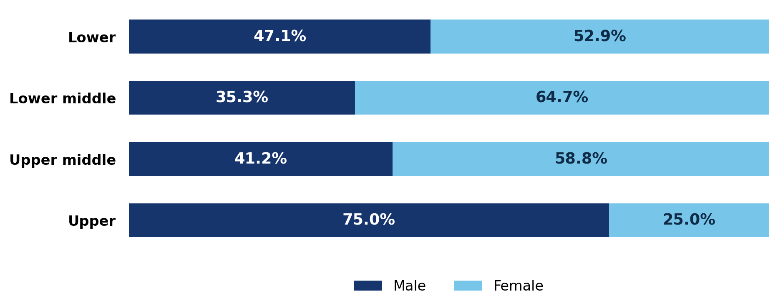
Key: dark blue = male; light blue = female. Employees are ranked by hourly pay and split into four groups, from the lowest-paid quarter to the highest-paid quarter. Each bar totals 100% of that quartile; for example, the upper quartile is 75.0% male and 25.0% female.

08 ANALYSIS
We welcome the opportunity to report on our gender pay gap as part of our ongoing commitment to transparency and inclusion. The data reflects the current structure of our organisation, including the roles and seniority levels held by employees across different functions.
While the figures highlight some areas for consideration, we are satisfied that our pay practices are aligned with our policies and values. We will continue to monitor developments in this area and remain open to identifying further opportunities to support equality in the workplace.

09 CONCLUSION
Through its own actions and through the shared learning on relevant initiatives being promoted across the organisation, Carraig Laundry intends to continue to implement appropriate actions to assist in addressing the gender pay gap.
Carraig Laundry looks forward to working with its employees on these issues in the time ahead.

